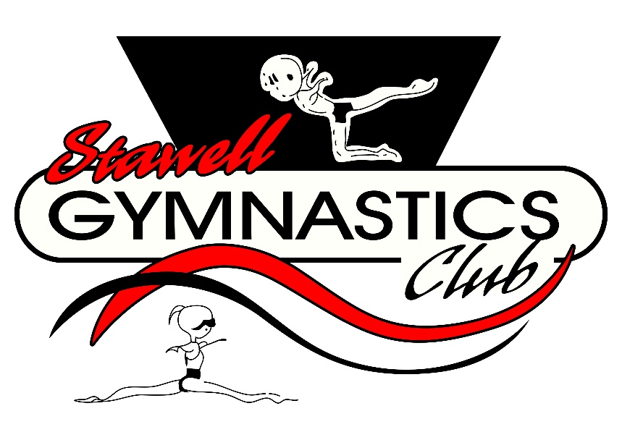
Term Fees 2023

Please note that Term fees are due by week 4 of each term.
Same Fee for each term.
Gym Vic Rego & Insurance now included.

- 1 Hour Class $100
- 1 ½ Hour Class $135
- 2 Hour Class $170
- 2 ½ Hour Class $195
- 3 Hour Class $215
- 3 ½ Hour Class $245
- 5 Hours of Classes $300
- 6 Hours of Classes $340

Account Details

Name: Stawell Gymnastics Club
BSB: 063528
Account Number: 10067548
Please use your child/children’s full name as description

